NSPCC Partner Activation Instructions
There is a new menu option under the Settings Menu called Partners
Select the NSPCC option
This page provides some information and links describing the NSPCC / IRIS Partnership
Click the Add button to make the NSPCC bank account available for your payment items
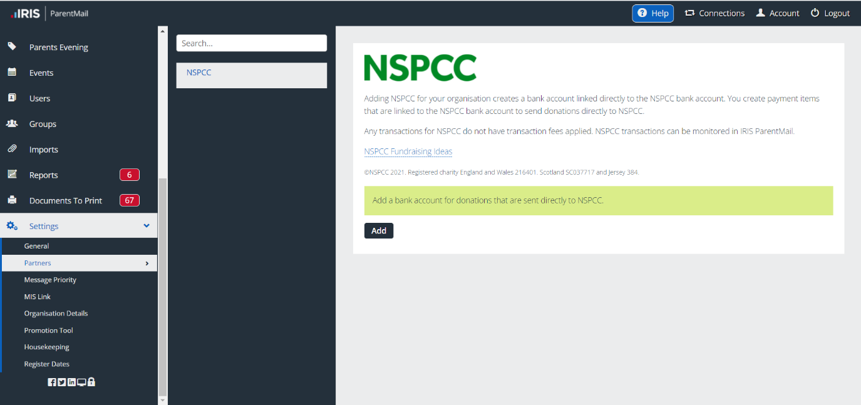
The NSPCC bank account will now be available in the Bank Account drop down list when creating a payment item
