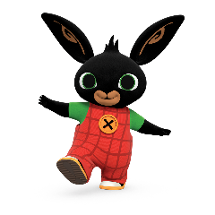
We are delighted to be partnering with the NSPCC for a third year in a row for Childhood Day. The annual day of fundraising for the NSPCC, Childhood Day brings everyone in the UK together to have fun and help protect children.
The TV series, Bing, mirrors a pre-schooler’s real-life experience. From the joy of a new daily discovery to the disappointment of things not going quite as planned, Bing tells the small stories that make up those first experiences which can feel so big and shape our children’s understanding of the world and their potential within it.
Each episode of Bing has been developed with educational and developmental experts to ensure that the stories shared support healthy child development – helping young audiences grow their emotional, language and reasoning skills.
This year the theme of Childhood Day 2024 is ‘Play your part’, encouraging people all across the UK to take part in the Childhood Day Mile. Whether this is with their nursery, school or at home, everyone is encouraged to get involved with the NSPCC’s fundraising efforts. Play is a key part of the series, as Bing, Flop and their friends play together – in living rooms, gardens, at Amma’s Creche, in the park or the Howly Woods. Play is essential to child development supporting mental, emotional and social health as well as physical growth and coordination. You can find out more about the importance of play at bingbunny.com.
Childhood Day is a fun celebration of childhood and a chance to raise money for an important cause. The Childhood Day Mile may be too much of a challenge for little legs to walk, but there are lots of different ways you and your Bingster can move your mile. Instead, you can take it in turns to complete your mile as a team in a relay. However you participate in Childhood Day, you will be playing your part to keep children safe. Thank you.
We wish you a very happy Childhood Day!
Team Bing

