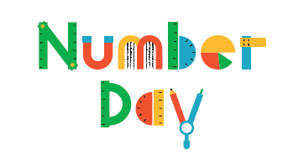
We’re counting down to Number Day 2018!
Dear <name>,
We are delighted to be supporting the NSPCC by taking part in their Number Day on Friday 2 February 2018.
Children deserve an equal start in life
The NSPCC believes that all children deserve a childhood free from harm but, sadly, that’s not the case for many children. That’s why the NSPCC is fighting for every childhood and working to help keep children safe from abuse.
The NSPCC needs our support. By raising money, we can help to fund their vital services such as Childline – the helpline that’s always there for children and young people whatever their problem or concern.
Making maths meaningful
Number Day is a great way to make maths fun and bring about a positive, ‘can-do’ attitude towards it.
<Delete where applicable>
(On 2 February we will be using fun curriculum-based maths challenges designed by the NSPCC, Oxford University Press and Maths on Toast. To help raise money for the NSPCC, we are asking pupils to collect sponsorship / donations using the enclosed sponsor form.)
(On 2 February we will be taking part in Dress up for Digits and pupils will be invited to wear an item of clothing with a number on it (football shirt, cap, netball shirt or even a onesie!). To help raise money for the NSPCC, we are asking for a suggested donation of £2, and we’d love everyone in the school to take part in this special event.)
It all adds up
We’re looking forward to all the fun of Number Day, and we really appreciate your support. All the money we raise at <school> will make an enormous difference to children today and help change the lives of children tomorrow.
Thank you.

Best wishes,
<Name>
<Your school details>
You can find out more about the NSPCC’s work at nspcc.org.uk
To find out more about keeping children safe online, visit nspcc.org.uk/onlinesafety

