Have
Fun!

I’m taking part in
NSPCC Childhood Day!
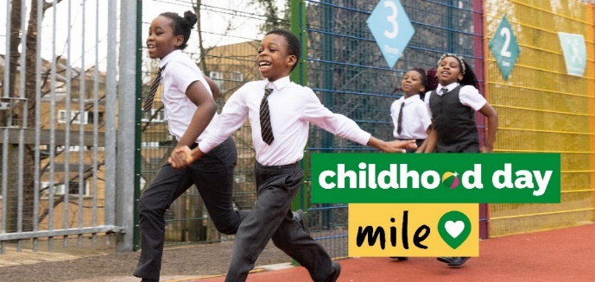
Name
Classroom
School/Nursery Name

I am taking part in the NSPCC Childhood Day Mile at school. Your donation will help
to support NSPCC services such as Childline, Helpline and the Speak Out Stay Safe programme that has reached 90% of primary schools.
Please make a difference to a child’s life by scanning the QR code below.
  £4  could help answer a  child’s call to Childline. |  | 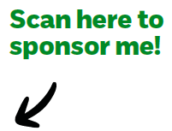  Scan here to  sponsor me!

Thank you! You’re amazing!

Retail Sponsor

My Supporter List
Name | Donation

