

Dear <name>,
(Teacher – please delete/amend below as appropriate)
We're delighted to be supporting the NSPCC by taking
part in their Yoga Zoo Challenge.
Everything the NSPCC does protects children
and helps keep them safe – today and every day.
The NSPCC need our support more than ever. By raising money,
we can help fund their vital services, like Look, Say, Sing, Play,
which gives parents and carers free tools to help them to have
higher quality interactions with their little ones.
Visit nspcc.org.uk/brainbuilding to find out more.

Our Yoga Zoo Challenge
(Teacher – please delete/amend below as appropriate)
We’ll be spending a day on <date of your event> doing fun and gentle yoga, as well as age-appropriate mindfulness. Yoga encourages little ones to get active, helping them build muscle strength and improve their motor skills. Alongside that, yoga and mindfulness can help with emotional wellbeing, resilience, and behaviour. We’ll also be doing activities like colouring in and breathing exercises, so children can enjoy calm and mindful moments together.
<For our yoga challenge, we ask that children come into nursery dressed up as their favourite animal.>
We ask that children bring in a donation of <give details of what donation you're asking children to bring in and anything else they need>
Fundraising
(Teacher – please delete/amend below as appropriate)
- We’ve set up a JustGiving page (insert link).
- Please donate and share with friends so we can support the NSPCC.
- Please send in a donation to support the NSPCC’s work in a sealed envelope.
- Please donate via Giftt. You can < find the QR code below/ sponsorship form including the QR code attached.> Please donate and share with friends so we can support the NSPCC.
- (Teacher – please copy and paste the
QR code here from your Giftt page.
Don’t resize the code, and check it works
when scanning before printing the letters)

It all adds up
All the money we raise at <nursery> will
help keep children supported and safe.

Thank you.

Best wishes,
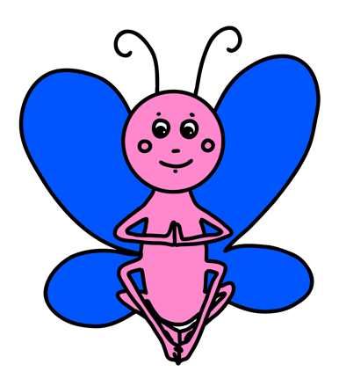
<Name>
<Your school details>

