Authored by: The IICSA Changemakers Survivor Advisory Community and the IICSA Changemakers
March 2025

IICSA Changemaker Engagement session with survivors: VCOP

Our gratitude:

Thank you to every individual survivor who inputted into this paper and surrounding work.
Sharing your very personal and visceral reflections and experiences with us, is an act of courage and trust that we gratefully and humbly receive. Thank you for your determination and unwavering passion in making a difference for survivors now and in the future.
To any survivor reading this, who may have chosen not to/or cannot disclose to anyone or take part in any of the participation activities, please know that you are welcome here. Your experiences are valid and your level of visibility and disclosure does not define your worthiness or credibility as a survivor. Please know that you are not alone, you did not make this happen and it is not your fault.
And finally we honour survivors who have lost their lives, who are not here today because of the failings of the systems around them. We hope you find rest and we continue this fight in your memory.
You are seen. You are worthy. You are important.
To every practitioner who shared their time and expertise in contributing to this piece, and to the work in a wider sphere; thank you for your tenacious allyship, we need you and we are grateful for you.
To everyone involved in the original seven yearlong inquiry, thank you for your labour and bravery.
To all the Changemaker members, who continue to put their commitment and support to pursuing action after the inquiry, thank you.

- Introduction

Co-ordinated by the NSPCC, the IICSA Changemakers are a group of 68 like-minded organisations which have united across the sectors to inspire a national mission to prevent child sexual abuse and provide much improved support to victims and survivors. All IICSA Changemaker organisations contribute to the successful running of the group by investing their time, expertise and access to networks to achieve the following ambition:
“Inspire a national mission to prevent child sexual abuse and provide much improved support to victims and survivors”

- Methodology

“Nothing about us, without us”
We recognise that victims and survivors are not all the same and not every individual who has experienced child sexual abuse will resonate with the term ‘survivor’. For continuity in this document, we will use the word ’survivor’ but we want to powerfully acknowledge that this is not a label that defines a person.
The IICSA Changemakers Survivor Advisory Community are a group of 31 adult survivors of child sexual abuse that collaborate, shape and influence the work of the wider Changemaker group. All members sign up to a Code of Conduct and Terms of Reference upon joining to ensure that the safety and confidentiality boundaries of the group are upheld and proactively protected.
Supported by the Survivor Participation Manager, all members can choose what level and layer of participation they wish to engage with. This includes choosing the spectrum of disclosure and identity they wish to share within the work. Participation and consent can be withdrawn at any time without reprisal or judgement.
Our ethos is to uphold trauma informed, strength based, survivor centred approaches. In practice, this means recognising that survivors are not just the abuse they have experienced; but are whole, complex, nuanced and wonderful human beings that have a range of skills and expertise to be able to offer. It also means that the Survivor Participation Manager continually engages with anti-racist and intersectional learning around violence and abuse to ensure that unconscious bias does not compromise the integrity of the participation.
Safeguarding, risk management and boundaries are holistically embedded into the work we do to make sure that survivor safety (physical, emotional, psychological and spiritual) is at the forefront of all activities and requests. Healing is not a linear or binary feeling or process; we recognise that survivor wellbeing could be affected by their participation work so debriefs and peer support spaces are offered, as well as signposting.
Stage one was an anonymous survivor survey conducted in the summer of 2024 with a subsequent follow up survey in winter 2024 with matching focus group work to listen to themes, reflections and begin to forge a direction for our more intensive work upcoming in stage two.
The questions set covered four core areas: awareness, content, communication and mechanisms.
- For awareness we looked at access to information about the Victims’ Code.
- For content we looked at the statutory guidance surrounding the Victim Code of Practice (VCOP) and tested the following principles:
The Victims’ Code must make provision for services which reflect the principles that victims and survivors require—
(a) information to help them understand the criminal justice process;
(b) access to services which support them (including, where appropriate, specialist services)
(c) the opportunity to make their views heard in the criminal justice process;
(d) the ability to challenge decisions which have a direct impact on them.
- For communication we are aware the Ministry of Justice (MoJ) want to look at bespoke communications that would work for different individual needs. So we aimed to test the appropriateness of the current communication for the groups we work with.

- For mechanisms within the Victims’ Code we were looking to explore the reality and effectiveness of a trauma informed approached. This included looking at the embodiment of safety, choice, collaboration, empowerment, and cultural humility within the Victims’ Code.
The results of the survey showed us several core elements that required further research and understanding which is why the second survey and focus groups were run.
Stage two was a group of survivors from the IICSA Changemaker Survivor Advisory Community who worked on the results from stage one and took those results to the next level by explaining the context, sharing their expertise and diving into focussed areas.

- Key findings

The twelve rights within the Victims’ Code represent the journey a survivor should expect in terms of support or how the justice system should operate if they choose to engage with it. IICSA Changemaker Survivor Advisory Community members and practitioners in this field have demonstrated that the communication of and monitoring of the rights are in themselves re-traumatising to survivors as the onus is on a survivor to learn and navigate a complicated system.
The Victims’ Code has the power to be a benchmark that is used for transparency of a good system where survivors are supported through a process that has been designed for them to fully understand their rights and ensure they are able to access and make best use of services they are entitled to. To achieve this the communication and monitoring of the Victims’ Code require substantial work to move the onus away from the survivor and onto the professionals the Victims’ Code was intended for.
Currently the transparency of reporting and monitoring of the Victims’ Code is not at an acceptable level. The introduction of the 2024 Victims Act and subsequent statutory guidance will see significant changes when justice bodies are compelled by legislation to record and report against the Victims’ Code. This focus may in turn help the quality on how VCOP is delivered but support will be needed on the mechanism, style and training of the Victims’ Code. An interactive bespoke Code written and made available in a genuinely trauma informed way will support professionals as they guide survivors through their rights.

- Communication
Communication key points
- Survivors need to be supported through the information in a meaningful and bespoke way so they understand their rights, ensuring that a good level of service and support can be delivered.
- The current format of delivery needs improvement. Bespoke clear and trauma informed language must be used by professionals that are culturally aware and competent.
- Enhanced rights need to be focused on and fully communicated in order for those they are intended for to be able to access them meaningfully.

Evidenced from our surveys and conversations with survivors and partners:
Survey work:
Through the survey work survivors shared with us that the Victims’ Code document felt “cold, clinical and pointless”. They asked for a variety of accessible formats including online versions to be made available. Also raised was considering the power dynamics of who hosted and shared the information, as this has a relevant and huge impact on a survivors ability to access the Victims’ Code meaningfully. This is why access and overcoming barriers are such a prominent theme.
Participants also shared that its “Not what they say but how its written or delivered, the tone isn’t focussed on believing the victim/survivor”. Crucially, a professionals understanding of stress and trauma responses is key to being able to deliver information in a meaningful and safe way that focuses on ‘meeting a survivor where they are at’ and ensuring they feel believed and supported. This moves us to ‘ideal victim theory’ and concerns survivors have about not being believed as they don’t fit the assumption of an ‘ideal victim’. 90% of respondents felt negatively impacted by a professional’s bias and misunderstanding of what a victim/survivor ‘should look like and how they behave’.
95% of respondents felt their experience would have been improved if the professional they worked with used trauma informed language and had an authentic understanding of what ‘trauma informed’ means in practice.
One participant highlighted the importance of how right four (victims have the right to be referred to support services and have their needs assessed.) is critical to be communicated really well. That you can access services without going through the justice system.
“How is a victim classed? What about child sexual abuse victims that never go through the justice system, is there a version of this available for them for support?”
With another adding “Justice is not just criminal, it’s personal, we have to feel it and see it, so what does this Code say about justice for victims/survivors that never fully go through the Criminal Justice process?“
“The Victims’ Code is okay and does its job in terms of process, but it’s the way that it’s communicated (or not communicated) that creates the harm. The lack of implementation and careful delivery is retraumatising.”

Interviews:
“There is still a need for awareness of different cultures/cultural competence alongside VCOP, as this is especially important for survivors in communities with specific barriers. There’s a lack of data on the intersection of racism within VCOP and the intergenerational tolerance of child sexual abuse within some communities”.
Aunee (she/her) IICSA Changemaker Advisory Survivor Community member

“You can’t advocate for yourself if you don’t know what you’re entitled to in the first place.”
Ella (she/they) IICSA Changemaker Advisory Survivor Community member

“VCOP will have no benefit if not communicated from the top. If those enforcing this policy don’t stress it’s importance then the sad reality is that none of the actionable parties will give it the platform and communication it desperately needs.”
Poppy (she/her) IICSA Changemaker Advisory Survivor Community member

“I wonder how much of the training that was left in for Police on VCOP compares to that of the rights of people in custody/those accused of a crime.”
Chrissy (she/her) IICSA Changemaker Advisory Survivor Community member

“Very few survivors have even been told about the Victims’ Code. Many don’t know what it is. Sometimes it is in a general pack but it is lost in a lot of overwhelming information. Victim Support are good at telling survivors about it though.”
“It should be communicated, discussed, a chance to explore it together needs to be made, not just a leaflet given out.”
“The vast majority of survivors are far too upset and traumatised to be able to read and digest the information from a leaflet.”
Breaking the silence, who provide support for men and boys from racialised communities affected by sexual abuse

“The way that the Victims’ Code was shared didn’t make out it was actual rights and therefore not seen as important.”
Galop who support LGBTQIA+ people who have experienced abuse and violence

“People can’t get to the information they need because the language is not adjustable or digestible by someone who doesn’t know the system. It can be overwhelming and therefore people disengage and don’t know what is relevant to them. Too generalist, not bespoke, intended for all victims/survivors but if you have enhanced rights it doesn’t really take you through that.”
Galop who support LGBTQIA+ people who have experienced abuse and violence

“It’s all how you present the information, it needs to be accessible, for example info graphics and easy read version. A video is one of the best ways for impact for those who access information differently.”
The Havens who are specialist centres in London for people who have been raped or sexually assaulted.

“Poor management of survivors expectations regarding the criminal justice process, particularly around timescales, is an ongoing issue.”
“Women’s needs should be assessed regularly, as internal and external factors impact aspirations and capabilities.”
Beyond the Streets collaborate to ensure women are not compelled to sell sex and to create routes out of prostitution by working with others including those with lived experience

It’s important that when a professional is engaging with a victim/survivor they have the training to support their language within that interaction. For example, the phrase “They will not engage with services” is often heard when a professional has experienced resistance in initially signposting services, when in fact the ‘Child exploitation and abuse: an appropriate language guide’ produced for the CSE Taskforce by The Children’s Society and NAPAC tell us that this fails to acknowledge a child or person’s previous or ongoing experience of engaging with services and may impact their perceptions of support. People, especially children or young people who have become known to statutory services, may be expected to speak to lots of professionals. Impacts of funding, capacity, and staff transitions can cause survivors to feel let-down, forgotten and unsupported. This also implies that services are seen as safe and supportive to all children and people and doesn’t recognise negative experiences the individual may have had from professionals or those in positions in power. This also fails to acknowledge the ongoing risk or harm the person may be experiencing which prevents them from seeking or accepting support. This term also fails to acknowledge the complex process that an individual may go through to even understand that their experience is abuse.

- Mechanisms for delivering and monitoring the Victims’ Code
Mechanisms for delivering and monitoring the Victim’s Code key points
- Timescales and procedures within the support and justice system need to be made clear so expectations can be set
- Eligibility as a ‘victim/survivor’ needs to be clear and then access points or pathways made easily attainable
- The detailed process of VCOP would be more beneficial if it could be accessed in triage format (where a user can be supported to access their crime type against the rights) and split up into easier to absorb sections such as justice process, non-justice and after the case
- The onus is currently on the survivor to have the energy, determination and mental capacity to find the information on and uphold VCOP. Many justice providers such as police have a public protection focus and aren’t being supported to deliver survivor support.

Evidenced from our surveys and conversations with survivors and partners:

Survey work:
Our participants shared that the onus is on the survivor not the providers to know about and then navigate the Victims’ Code. There remains a need for neutral language that isn’t accusatory and for the platform itself to be hosted by a non-government system. Splitting up the elements of justice process, non-justice, after the case, before the case, would mean survivors weren’t having to sift and process every item of information, some of which might not be relevant for their situation.
43% of respondents shared that the format of VCOP prevented them from understanding and accessing their rights.
85% of respondents shared that a triage style approach of helping get to the right information in VCOP faster would have been beneficial.
“VCOP is self-driven by the victim, which is not how it should be, so the power dynamics of that are in itself harmful.”
“The Victims’ Code itself is trauma informed but it must be about the person who’s delivering or disseminating it, if they are not trauma informed or talking about it appropriately then it no longer works and causes harm.”
“The onus is on the survivor to have the energy and determination and mental capacity to find and uphold the Victim’s Code, it doesn’t feel like the police are trained. Their focus is on public protection not on supporting victims/survivors to navigate the system.”
“Different types of crime get different levels of attention with VCOP, it doesn’t feel like child sexual abuse where the perpetrator is deceased or incapacitated and not a risk, is considered with the same attention to detail with VCOP as for example, a current homicide.”
Several contributors commented on the right of complaint and how difficult the process is “Made a complaint, received inappropriate rebuffs and obstacles, had to rely on personal perseverance to follow it through rather than the system actually supporting or working.”
“To be able to complain you need to know what good practice ‘should’ be or what your rights are. VCOP doesn’t do this, it doesn’t help victims/survivors know their rights, it’s about outlining a baseline system process it doesn’t cover best practice and wellbeing.”

Interviews:
“Definitely need standardised training, but also trauma training so professionals understand trauma responses, the neurological impact on memory, hypervigilance, etc, so that bias is addressed. “
Chrissy (she/her) IICSA Changemaker Advisory Survivor Community member

“As a kid your perpetrator can make you believe they love you and that you love them! you don't want to send the person who you love to prison! doesn't make me any less abused and them in anyway less an abuser!!!”
Ella (she/they) IICSA Changemaker Advisory Survivor Community member

“Everything fell onto my ISVA and I felt ‘lucky and grateful’ for having a good ISVA. But from being in the session with other survivors I can now see that the bar for justice professionals was so low, that the bare minimum standards were barely being met but I was being made to feel grateful for it. I didn’t know what it should have been.”
Laura (she/her) IICSA Changemaker Advisory Survivor Community member

“There is no set timeline or procedure in VCOP. Therefore how could they support survivors.”
Galop who support LGBT+ people who have experienced abuse and violence

“Identification as ‘victims/survivors’ and eligibility for support services
- The VCOP mandates that victims be identified as such before they can access entitlements. However, children and young people whose ages are disputed may face delays or outright denials of support as they may not be initially recognized as children, and thus not as victims. The often lengthy and contested age-dispute process compounds this problem.
- Additionally, lacking a clear legal status as children, they may be placed in adult facilities, which denies them access to specialized services tailored to young victims, like age-appropriate counselling and appropriate wrap-around support.
- We also know some children and young people face criminal charges for steering boats, now deemed an immigration offense. Many end up in adult courtrooms and even in adult prisons, which further highlights the dysfunctionality of the system and poor protections.
Access to special measures for children and vulnerable witnesses
- The VCOP offers special protections for child victims and vulnerable witnesses, such as giving evidence via video link, using screens in court, or having intermediaries to support communication. For children and young people seeking asylum, these measures are crucial to minimize re-traumatization during legal proceedings.
- Unfortunately, age-disputed children and young people may be denied these measures until their age is definitively established, creating a gap in protections for those treated as adults until proven otherwise—an intimidating and often distressing experience for children and young people seeking asylum involved in court cases.
- Many of these children and young people have been trafficked or have experienced abuse, including sexual abuse, and they often struggle to disclose sensitive information. When they are disbelieved about their age, it further damages their ability to serve as ‘credible witnesses’ or give evidence.
Barriers in access to information and understanding of legal rights
- The VCOP emphasises the importance of providing clear information on legal rights and case progress. For children seeking asylum, barriers such as language, trauma, and unfamiliarity with the UK legal system make it difficult to access and understand this information.
- While the Victims’ Code mandates that information be accessible, there’s often a lack of adequate interpretation services or culturally relevant communication, particularly at initial stages of their engagement with authorities.
Challenges in Accessing Trauma-Informed Support
- The VCOP envisions a support system that addresses the psychological needs of victims, which is essential for children who have likely endured trauma. Many children and young people seeking asylum face complex trauma due to violence, persecution, or exploitation.
- However, in practice, the criminal justice system lacks the specialised training and resources to provide trauma-informed care to young people seeking asylum. Age-disputed children often do not receive mental health support until their age is confirmed—by which point delayed intervention may have worsened their trauma.
- Moreover, we see children sentenced in adult courts when the Home Office visually assesses them as over 18 at the port of entry. These children face compounded trauma from the circumstances that led them to leave home, the perilous journey, and their experiences in the UK asylum system. Being placed in adult systems without safeguards only worsens their situation.
Navigating the intersection of immigration and criminal justice systems
- Age-disputed children and young people are subject to both immigration and criminal justice processes, each with distinct protocols and standards. The VCOP applies solely within the criminal justice context, meaning its protections do not automatically extend to the immigration system.
- For instance, children who may be victims of trafficking or abuse are often viewed primarily through their immigration status rather than their needs as victims. This discrepancy can prevent full VCOP protections from reaching children and young people seeking asylum, especially in cases where immigration processes, such as detention or deportation, take precedence.
Challenges in accessing restorative justice and support services for minors
- While the Victims’ Code promotes access to restorative justice, these services are often less available to children and young people seeking asylum, particularly those whose ages are disputed. Restorative justice not only requires that the victim’s needs are recognised but also demands their informed participation.
- Age-disputed children may be overlooked or discouraged from accessing these services, thus missing out on a chance for closure or acknowledgment of their experiences. This limitation, coupled with their trauma, can mean that critical emotional and psychological needs remain unaddressed if they are viewed as adults.”
The Refugee Council who support and empower people who have made the heartbreaking decision to flee conflict

Accountability and transparency around the Victims’ Code
From the Victim’s and Prisoner’s Act 2024 we know that each criminal justice system body must keep under review how services are provided in accordance with the Victims’ Code (unless the person has good reasons not to). They (the Criminal Justice body) must also collect information, to be prescribed in future regulations, share this information with each other and the Police and Crime Commissioner, and review it. These regulations may include details on information to be collected and time periods, and before making regulations the Ministry of Justice must consult.
Police and Crime Commissioner’s must “keep under review whether and how criminal justice bodies which provide services in the police area provide those services in accordance with the duty in section 5(1).” They must provide the Lord Chancellor with the information on compliance collected, participate in a review of the information and provide the Lord Chancellor with “reports” on the review. This will be set out in regulations, which may include the time periods within which information or a report must be provided and the form that the information or report must be provided. The MoJ must consult on this.
The Lord Chancellor can also make arrangements for the collection of victims’ feedback.
The British Transport Police and Ministry of Defence Police must also collect information on Code compliance and share this and any review with the Lord Chancellor.
The Lord Chancellor and Attorney General, acting jointly, must keep Code compliance under review and publish an annual report on Code compliance and lay it before Parliament. The Lord Chancellor must also publish compliance information to “enable members of the public to assess” compliance. If the Lord Chancellor and Attorney General agree jointly that Code compliance in an area is “unsatisfactory” they may give the Criminal Justice agency (or PCC if the police) a “a notice setting out their reasons for being of that view”, having first consulted with the Victim’s Commissioner. This notice must be published.
When all these actions on transparency are brought into action it creates visibility of a fair and reviewed process for survivors both disclosed and non-disclosed to see how seriously Criminal Justice bodies take the Victims’ Code and its delivery. It offers insight into what is known as a complex and challenging landscape.

Terminology

CSA: Child sexual abuse
PCC : Police and Crime Commissioner
CJS: Criminal justice system
MOJ: Ministry of Justice
MoD : Ministry of Défense
AG: Attorney General
VCOP: Victims Code of Practice
The Victims’ Code: a common, shorthand way of referring to VCOP

Survey results : Summer 2024
Have you heard of the Victims Code of Practice?
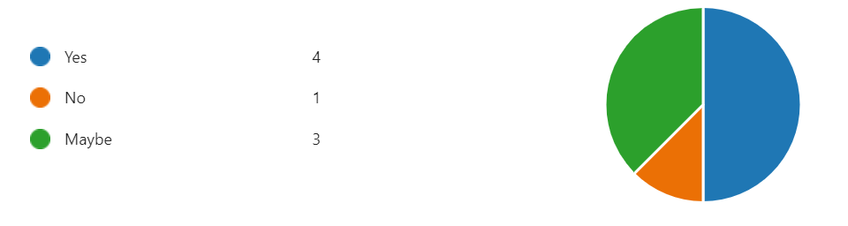
50% said ‘Yes’
13% said ‘No’
38% said ‘Maybe’.

Do you know where to find information about VCOP?
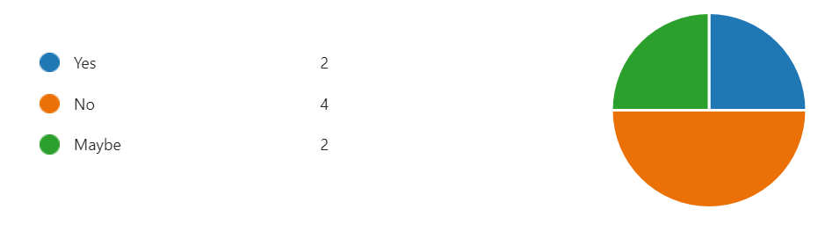
25% said ‘Yes’.
50% said ‘No’
25% said ‘Maybe’

There are 12 Rights within VCOP, are you aware of them all?
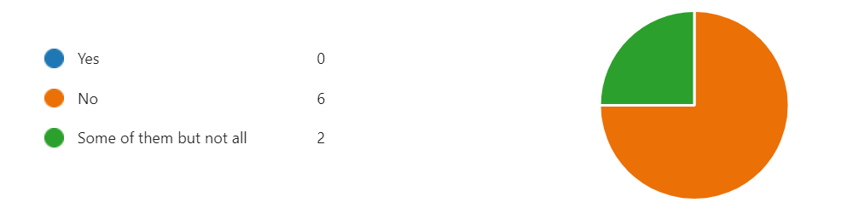
0% said ‘Yes’
75% said ‘No’
25% said ‘Some but not all
of them’

Are you aware of whose Duty it is to ensure VCOP is upheld?
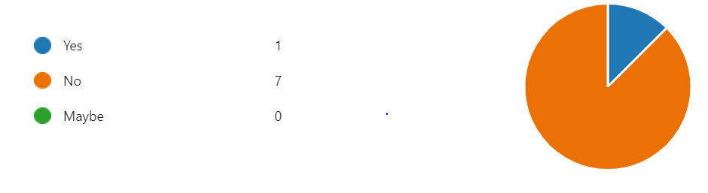
13% said ‘Yes’
88% said ‘No’
0% said ‘Maybe’

Have you had any personal experience with VCOP?
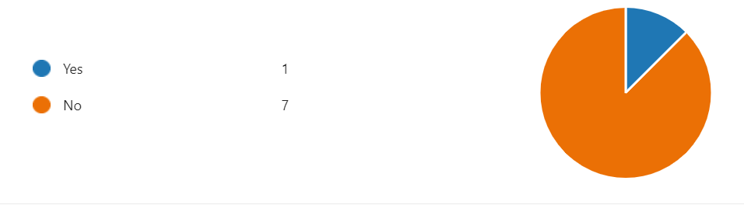
13% said ‘Yes’
88% said ‘No’
0% said ‘Maybe’

Child exploitation and abuse: an appropriate language guide 2024 NAPAC, The Children’s Society and the CSE Taskforce Appropriate-Language-Guide-Final-English-1.pdf

